Name: _____________________________________________________ Date: _________________ Period: _______
Lesson 1.1.2 Problems 1-11 to 1-15
1-11. Find the perimeter and area of each figure below. Review the Math Notes box in this lesson for help. Be sure to include the correct units in your answers.
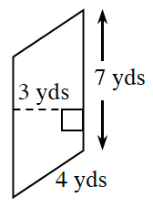
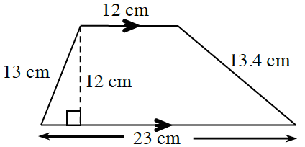
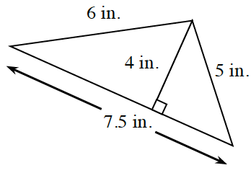
a. b. c.

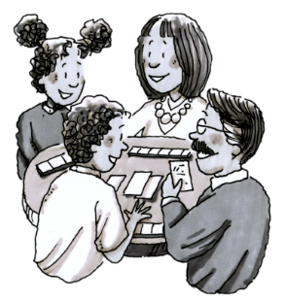
1-12. Think about games that you can remember playing with your friends or family.
  - Talk with your family and/or friends and list as many games as you can think of.

  - Label each game on your list as “fair,” “unfair,” or “I’m not sure.” For any game that you think is unfair, write down your reasons.

1-13. For each of the following pairs of events, predict which is more likely to happen and explain your reasoning.
- Event 1: You will win more than $1,000,000 in a lottery sometime in your life.
Event 2: You will learn to speak a language that you do not already know.

- Event 1: Your classmates will all wear the same kind of shoes on the same day.
Event 2: Your classmates will all eat the same thing for lunch on the same day.

1-14. Place a point on the number line and label the point for each of the following numbers: –4, 3, 0.5, –3.5, 0, 1, –2, 5.

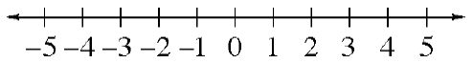

1-15. Maria was playing a game with her brother. She said, “I’m thinking of a number. When you multiply my number by six and add seven, you get twenty-five. What is my number?”

a. Find Maria’s number.

b. Explain how you figured out your answer to Maria’s number puzzle.

